**Selection of consultants**

**‑**

**Request for Expressions of Interest**

**The Water and Sewerage Company Inc. (WASCO)**

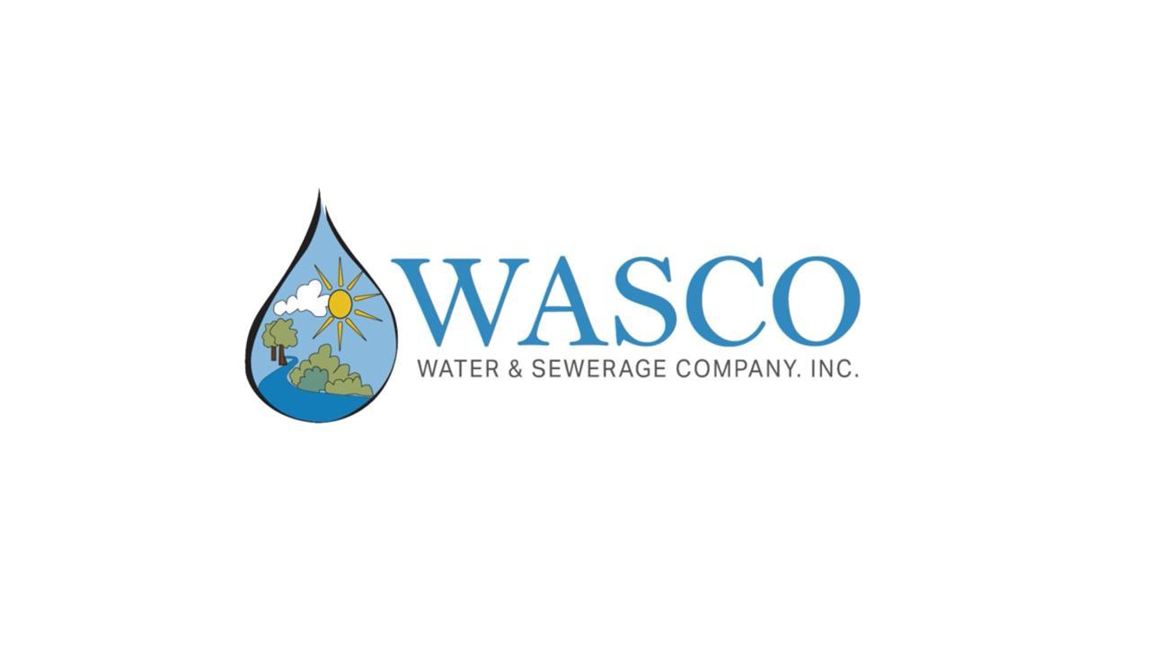

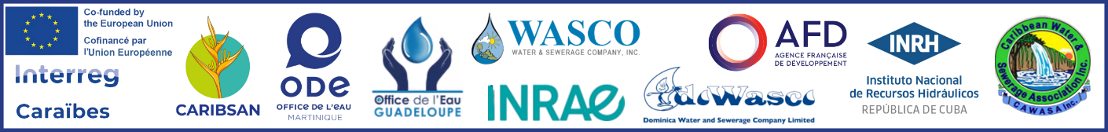

**AUGUST 2025**

**Template for the evaluation of expressions of interest**

The table below can be used to compile the shortlist of candidates. A table must be completed for each candidate. For each experience submitted by the candidate, check the boxes for the criteria that the experience meets.

Name of applicant:

|  |  |  |  |  |  |  |  |  |
| --- | --- | --- | --- | --- | --- | --- | --- | --- |
|  | ***Size of the contract*** | ***Nature of the Services*** | | | ***Technical area and expertise*** | | ***Location*** | ***Local representation*** |
|  | The contracts size (at least 50000 USD contracts, all taxes included) | Design studies for a treatment plant based on planted filters wetland technology in a tropical environment; | Supervision and validation of this type of work | Global experience in the sanitation sector, in particular on wastewater treatment plants based on planted filters wetland technology in tropical environments, | | Experience in trainings and in particular for this type of planted filters wetland technology | experiences in Saint Lucia or in any other Caribbean island | Presence of local Correspondents/Partners based in Saint Lucia |
| ***[Experiment A][1]*** |  |  |  |  | |  |  |  |
| ***[Experiment B]*** |  |  |  |  | |  |  |  |
| ***[Experiment C]*** |  |  |  |  | |  |  |  |
| ***[And so on.]*** |  |  |  |  | |  |  |  |
| **Total[2]** |  |  |  |  | |  |  |  |

The selection of candidates to be shortlisted will follow the rules set out below:

* The candidate must have at least one experience in each criterion; Failure to do so will result in the application being disqualified.
* The ranking of candidates is based on the highest number of criteria met (boxes checked).
* In the case of a joint venture, the experiences of all members will be added together to obtain a combined total.

***SAINT LUCIA***

***CARIBSAN II: CONSTRUCTION OF A PLANT-BASED FILTER-TYPE WASTEWATER TREATMENT PLANT***

***1- DESIGN***

***2- TRAINING AND SUPERVISION OF TEAMS FOR THE EXECUTION OF THE WORKS***

**CONSULTING SERVICES**

Expected start date of the mission: September 2025

Maximum duration of the mission : 2 years

**Expressions of Interest**

As part of a Caribbean cooperation project called CARIBSAN, on the theme of wastewater treatment plants including the islands of Saint Lucia, Dominica and Cuba, the Office de l'Eau de la Martinique (ODE), in collaboration with the operators of each island, has requested funding from the French Development Agency (AFD) and the European Union's INTERREG fund to build, in each of these islands, constructed wetlands in a tropical environment.

In Saint Lucia, in the Black Bay community the wastewater of about 600 inhabitants is currently collected by communal septic tanks with-out a soak away/ field drainage system, allowing for partialy treated effluent to flow into a near by river.

The wastewater treatment facility that will be built there will make it possible to clean up this sector by ommiting the septic tanks and connecting the network to the new treatment facility.

The estimate of the construction work is 390600 US$ including tax.

The Water Office of Martinique and its partner, WASCO, have obtained funding from AFD to finance the construction of the tropical wastewater treatment facility in Black Bay, Vieux Fort.

The Services of the consultant shall consist of:

* The design of the wastewater treatment plant in collaboration with WASCO;
* The training and support of company teams in the construction of a treatment facility such as filters planted with plants in a tropical environment";
* Supervision and monitoring of the works until its acceptance;
* Monitoring of the invoicing of work[3]
* Supporting the project owner in resolving any disputes with the construction company

WASCO invites Applicants to express their interest in providing the Services described above.

This request for expressions of interest is open to:

|  |  |
| --- | --- |
| ✓ Consulting firms | * Individual consultants |
|  |  |
| * NGO | * Joint venture between NGO(s) and consulting firm(s) |

The eligibility criteria for AFD financing are specified in paragraph 1.3 of the "Guidelines for the award‑ of contracts financed by AFD abroad", available online on the AFD website: <http://www.afd.fr>.

The Applicant may submit only one application, either on its own behalf or as a member of a joint venture. If an Applicant (including a member of the joint venture) submits or participates in more than one application, all such applications will be rejected. However, the same Sub-Consultant may be involved in more than one application.

If the applicant is a joint venture, the expression of interest must include:

* a copy of the joint venture agreement entered into by all members,

or

* a letter of intent to sign a joint venture agreement, signed by all members and a copy of the proposed agreement,

In the absence of this document, the other members will be considered as Sub-Consultants.

The experiences and qualifications of sub-consultants are not taken into account in the evaluation of applications.

Interested applicants must provide information proving that they are qualified and experienced to perform these services. To this end, documented evidence of recent and similar services must be presented.

A list of up to fifteen (15) references will be provided to the Client in response to this Expression of Interest.

The similarity of the experiments will be determined on:

* The contracts size (at least 50 000 USD contracts all taxes incuded);
* **The nature of the Services**

⬩ Design studies for a treatment facility based on planted filters wetland technology in a tropical environment;

⬩ Supervision and validation of this type of work

**The technical area and expertise**

⬩ Global experience in the sanitation sector, in particular on wastewater treatment plants based on planted filters wetland technology in tropical environments,

⬩ Experience in trainings and in particular for this type of planted filters wetland technology

* The location: experiences in Saint Lucia in particular and in any other Caribbean island.

The Client will also consider the suitability of the Expressions of Interest in light of the following criteria:

* *Presence of local Correspondents/Partners based in Saint Lucia*

Among the submitted applications, WASCO will shortlist a maximum of six (6) Applicants, to whom the Request for Proposals to carry out the Services shall be sent.

Expressions of interest must be submitted to the address below by: **(This will be based on the date of the posting of the request. The footnote recommends it being 3 weeks after posting)**   
*[insert date]*[4].

***Water and Sewerage Company Inc***

***Chief Executive Officer (C.E.O)***

***L’ Anse Road, Sans Souci Castries P.O Box,1481***

**Telephone: 1 (758) 457-3900/452-5344 – St Lucia; Codes – 1 (758)**

**Email:** **[wascocorp@wascosaintlucia.com](mailto:wascocorp@wascosaintlucia.com)**,

These Expressions of Interest must include :

1. The letter of expression of interest signed by the Applicant or representative of the joint venture ;
2. a copy of the joint venture agreement or a copy of the letter of intent to sign a joint venture agreement if the Applicant is a joint venture ;
3. The Applicant’s presentation (document proving its legal existence, organizational chart, staff, financial statements/turnover over the last 5 years) ;
4. The Applicant’s references ;
5. An attestation of non-bankruptcy ;
6. The signed Statement of Integrity, Eligibility and Environmental and Social Responsibility.

The order of the above documents must be respected in the presentation of the Expression of Interest submitted.

Interested candidates can obtain further information at the address below during office hours:

**Working hours of operations – Monday to Friday (7:30 a.m to 4:30 p.m**[5].

Project Management Unit – Maurice Norville (758) 482-0121-[mauricenorville@wascosaintlucia.com](mailto:mauricenorville@wascosaintlucia.com),

Chief Operations Officer-Aly Anthony (758) 482-0003- alyanthony@wascosaintlucia.com.

Annex to the Request for Expressions of Interest   
(to be included with the application, signed and not amended)

Statement of Integrity, Eligibility and Environmental and Social Responsibility

Offer reference name/Proposal/Signed contract[6] :

***CARIBSAN II: CONSTRUCTION OF A PLANT-BASED FILTER-TYPE WASTEWATER TREATMENT PLANT*** (the **"Contract"**)

At: **Water and sewerage Company Inc** (the **"contracting authority"**)

1. We acknowledge and accept that the French Development Agency (" **AFD** ") only finances the projects of the Project Owner on its own terms, as defined in the Financing Agreement which directly or indirectly binds it to the Project Owner. The contracting authority retains sole responsibility for the preparation and implementation of the procurement process and the performance of the contract. As a result, there is no legal link between AFD and our company, our joint venture and our subcontractors. The contracting authority may also designate the customer, employer or purchaser, as the case may be, for the procurement of works, goods, facilities, equipment, consultancy services or non-advisory services .
2. We hereby certify that neither we, nor any person acting on our behalf,[7] nor any of our joint venture members, nor any of our subcontractors, are in any of the following situations :

2.1 Be bankrupt, liquidated or cease our business, have our business administered by the courts, have been in receivership or be in a similar situation arising from similar proceedings;

2.2 Having been, within the last five years, subject to a final administrative sanction, a final conviction by a competent authority or any other non-judicial resolution[8] having an extinguishing effect on public action, i.e. (i) in the country where we are incorporated, (ii) in the country of performance of the Contract, (iii) in the context of the conclusion or performance of a Contract financed by AFD, (iv) issued by an institution of the European Union, or (v) issued by a competent authority in France, for:

1. Prohibited Practices, as defined in Section 6.1 below, or for any other breach committed in connection with the making or performance of a Contract (in the event of such sanction, conviction or non-judicial resolution, we may include with this Integrity Statement, such as a compliance program, additional information showing that we (or the person acting on our behalf, the member of our joint venture, or our subcontractor) consider that such sanction, judgment or non-judicial resolution is not relevant to the Contract, if any);
2. Participation in a criminal organization, terrorist or terrorism-related offences, child labour or other offences related to human trafficking ;
3. Have created an entity in a different jurisdiction (i) with the intent to evade tax or social security obligations, or any other applicable legal obligation in the jurisdiction of its registered office, central government or principal place of business, or (ii) be an entity created with the intent to evade such obligations ;

2.3 Have had a fully settled termination of the contract against us within the last five years for a material or persistent breach of our contractual obligations during the performance of the contract, unless such termination has been contested and the resolution of the dispute is still ongoing or has not confirmed a full settlement against us;

2.4 Have been declared ineligible by one of the multilateral development banks that signed the Mutual Recognition Agreement of 9 April 2010[9] (in case of ineligibility, we may attach to this Integrity Statement additional information showing that we consider such ineligibility to be irrelevant under the Agreement, if applicable);

2.5 Have not fulfilled our tax obligations relating to the payment of our taxes or social security contributions in accordance with the legal provisions of our country of incorporation or the country of the contracting authority;

2.6 Creating falsified documents or making false statements in providing information requested by the Contracting Authority as part of the procurement and award process for this Contract.

1. We hereby certify that neither we, nor any party acting on our behalf[10], nor any member of our joint venture, nor any of our subcontractors, nor any of our direct or indirect shareholders, nor any of our subsidiaries acting with our knowledge or consent:
   1. Are directly or indirectly subject to, controlled by, a person or entity subject to, or acting in the name of, or on behalf of, a person or entity subject to **individual sanctions** adopted by the United Nations, the European Union and/or France;
   2. Are directly or indirectly subject to, controlled by, a person or entity subject to, or acting in the name of or on behalf of a person or entity subject to sectoral **sanctions** adopted by the United Nations, the European Union and/or France;
   3. Are ineligible to implement the Project due to any other international sanctions measures issued by the United Nations, the European Union or France.
2. We hereby certify that neither we, nor any party acting on our behalf,2 nor any of our joint venture members, nor any of our subcontractors, are [or have been *(in the case of refinancing a previously awarded contract)*] in any of the following conflict of interest situations :

4.1 Be a controlling shareholder of the Contracting Power or a subsidiary controlled by the Contracting Power, unless the resulting conflict of interest has been brought to the attention of AFD and resolved to its satisfaction.

4.2 Have a business or family relationship with a member of the project management services involved in the procurement process or the supervision of the resulting Contract, unless the resulting conflict of interest has been brought to the attention of AFD and resolved to its satisfaction;

4.3 Control or be controlled by another candidate, bidder, or consultant, or be under the same name as another candidate, tenderer, or consultant, receive grants from, or award grants to, another candidate, tenderer, or consultant, directly or indirectly, have the same legal representative as another candidate, tenderer, or consultant, maintain direct or indirect contact with another candidate, bidder or consultant that allows us to (i) have given and/or give access to information contained in our respective applications, offers or proposals that may distort competition (ii) influence them, or (iii) influence the decisions of the contracting authority;

4.4 Be engaged for a consultancy which by its nature is or may be in conflict with the task envisaged for the contracting authority;

4.5 Have prepared, be or have been associated with a natural or legal person who has prepared, specifications, terms of reference or other documents that have been used for the procurement process in question, and that contain provisions that may favour an application, offer or proposal;

4.6 Have or have had access to, have prepared for, be or have been associated with a natural or legal person who has or has had access to or prepared, specifications, plans, calculations, studies, or other documents that have not been communicated to all candidates, tenderers or consultants in the context of this procurement procedure, and thus give us an unfair competitive advantage;

4.7 In the case of a procurement process for works, facilities, equipment or goods, which we have been selected or proposed to be selected (or any of our affiliates who have been or are proposed to be selected) to carry out the supervision or inspection of the Services under this contract.

1. If we are a public entity or a public company, to participate in a competitive procurement process, we certify that we have legal and financial autonomy and that we operate within the framework of commercial laws and regulations.
2. In the context of the procurement and performance of the Contract :

6.1 Neither we nor any party acting on our behalf,2 neither any member of our joint venture, nor any of our subcontractors, have committed or will commit any Prohibited Practice as defined in the document entitled "AFD Group's Policy for Preventing and Combating Prohibited Practices" available on the AFD Website.[11]

6.2 Neither Neither we nor any party acting on our behalf,2 Neither any member of our joint venture nor any of our subcontractors will acquire or supply [have acquired or provided *(in the case of a refinancing of a Contract already awarded)*] in sectors subject to a the United Nations, the European Union or France.

1. We hereby commit to and undertake to ensure that any party acting on our behalf2,  any member of our joint venture and any of our subcontractors agree to :

7.1 Comply with internationally recognized environmental standards, including international conventions for the protection of the environment and, in particular, take all reasonable measures to avoid or limit adverse effects on vegetation, biodiversity, soil, groundwater and surface waters, as well as persons and property resulting from pollution, noise, vibration, traffic and other effects resulting from our activities, in accordance with the laws and regulations applicable in the country where the Agreement is performed.

7.2 Implement environmental and social risk mitigation measures where indicated in the environmental and social management plan provided by the Employer, and ensure that emissions, surface discharges and effluents produced by our activities comply with the limits, specifications or requirements applicable to the Contract.

7.3 Respect workers' rights to wages, hours of work, rest and vacation periods, overtime, minimum age, regular payments, allowances and benefits, in accordance with the internationally recognized standards, including the fundamental conventions of the International Labour Organization (ILO), in accordance with the laws and regulations applicable in the country of performance of the contract; indicate these elements in a document annexed to our employees' employment contracts and made available to the project owner; and respect and facilitate the right of workers to organize and set up a complaint handling mechanism for direct or indirect workers.

7.4 Implement non-discrimination and equal opportunity practices, and ensure the prohibition of child labour and forced labour.

7.5 Maintain a record for each local staff member recording the hours worked by each person, the type of work, the wages paid, and the training received, and ensure that these records are available at all times for inspection by the contracting authority and authorized government officials, in accordance with applicable laws and regulations for the protection of personal data in the country where the contract is performed.

1. We, any party acting on our behalf2, the members of our joint venture, our subcontractors, our direct or indirect shareholders and our subsidiaries, authorize the FCA to conduct investigations and, in particular, to take cognizance of accounting documents and documents relating to the procurement and performance of the Contract, including, but not limited to, our internal processes and the rules related to compliance with international sanctions imposed by the United Nations, the European Union and/or France, and to have them monitored by the AFD.
2. We represent that we have paid, or will pay, any commissions, benefits, fees, gratuities or charges related to the procurement process or the performance of the Contract to the following third party(ies), for example, an intermediary/agent(*):

|  |  |  |  |
| --- | --- | --- | --- |
| **Name of the beneficiary** | **Coordinates** | **Goal** | **Amount (indicate currency)** |
| _________________ | _________________ | _________________ | ________________ |
| _________________ | _________________ | _________________ | ________________ |
| _________________ | _________________ | _________________ | ________________ |

(*): If no amount has been paid or is not due, indicate "None".

1. We undertake to inform the Employer without delay, who will inform AFD, of any change in circumstances regarding the above sections, including in the event of sanctions or embargo measures adopted by the United Nations, the European Union and/or France, after the signing of this Declaration.

Name: As :

Duly authorized to sign in the name and on behalf of:[12]

Signature:

Dated:

1. Each row will be a separate experience that is listed in the app.
2. The "total" in each column indicates the number of experiences that meet the criterion.
3. The information provided should enable interested candidates to decide whether or not to prepare an expression of interest. In particular, an estimate of the size of the market should be indicated (number of expert months or budget available, but not both).
4. The date indicated must be three weeks from the date of publication of the notice.
5.
6. In the case of a previously signed Contract to be refinanced.
7. Directors (including any person who is a member of the administrative or supervisory management body, or who has powers of representation, decision or control), employees or agents (whether declared or not).
8. Including a Judicial Public Interest Agreement (CJIP), a decision following an appearance on prior recognition of guilt (CPRC), a negotiated resolution agreement or any other similar form of transaction ending a criminal proceeding.
9. World Bank, Inter-American Development Bank, African Development Bank, Asian Development Bank and European Bank for Reconstruction and Development.
10. Directors (including any person who is a member of the administrative or supervisory management body, or who has powers of representation, decision or control), employees or agents (whether declared or not).
11. For your information, this policy can be consulted *via* the following link: <https://www.afd.fr/en/combating-corruption>.
12. In the case of a joint venture, insert the name of the joint venture. The person who signs the bid, proposal or application on behalf of the bidder, consultant or applicant must attach a power of attorney from that bidder, consultant or applicant.